Andrei Gaille B. Sioson
S2025101980
10/10/26

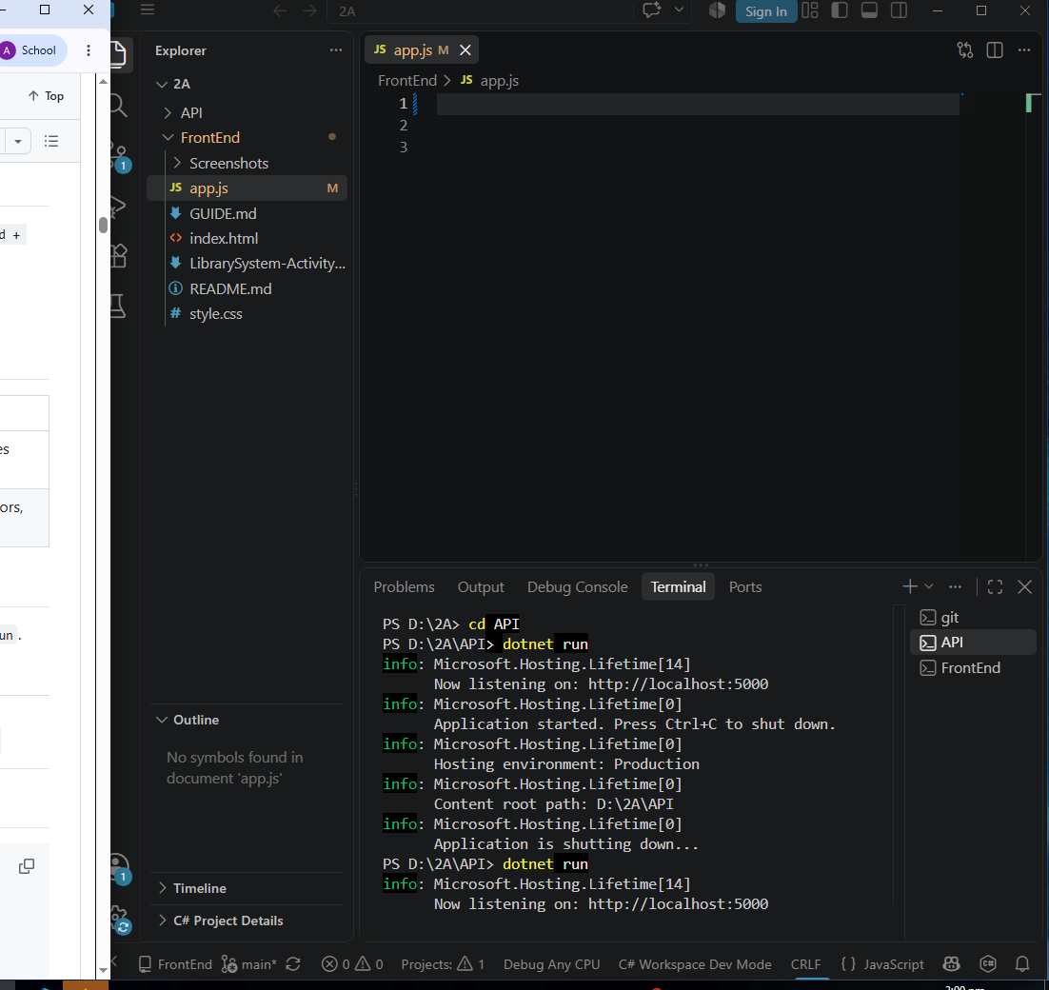
setup-01-api-running SCREENSHOT

Setup-02-api-books-json SCREENSHOT
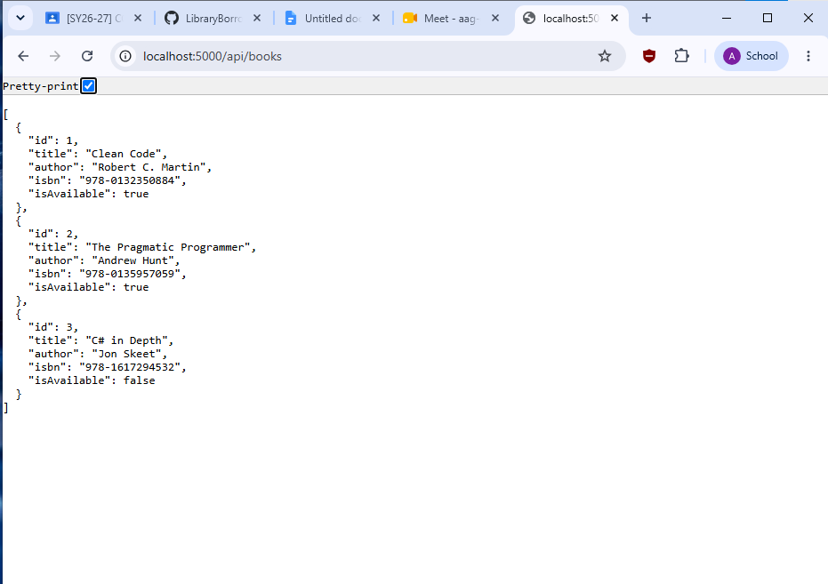

Part-01-settings-apifetch SCREENSHOT 1
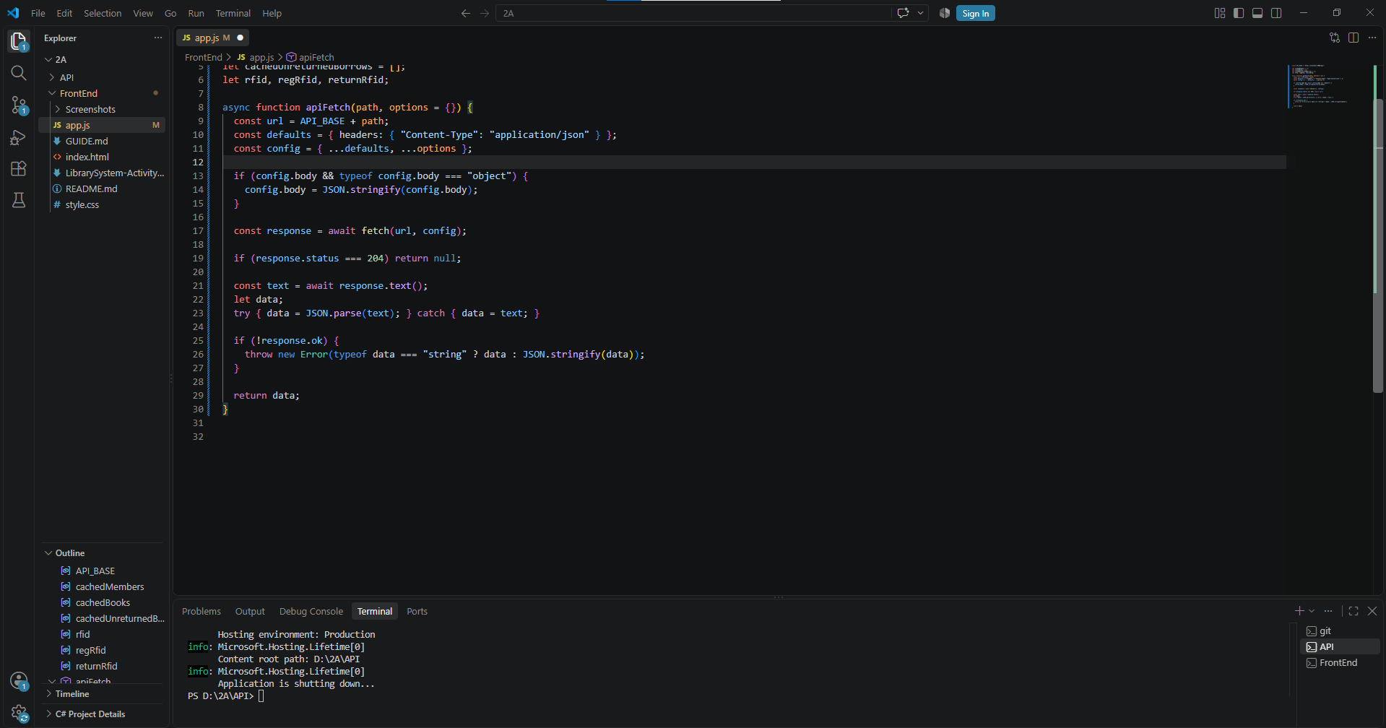

Part-02-showtoast SCREENSHOT 2
Function
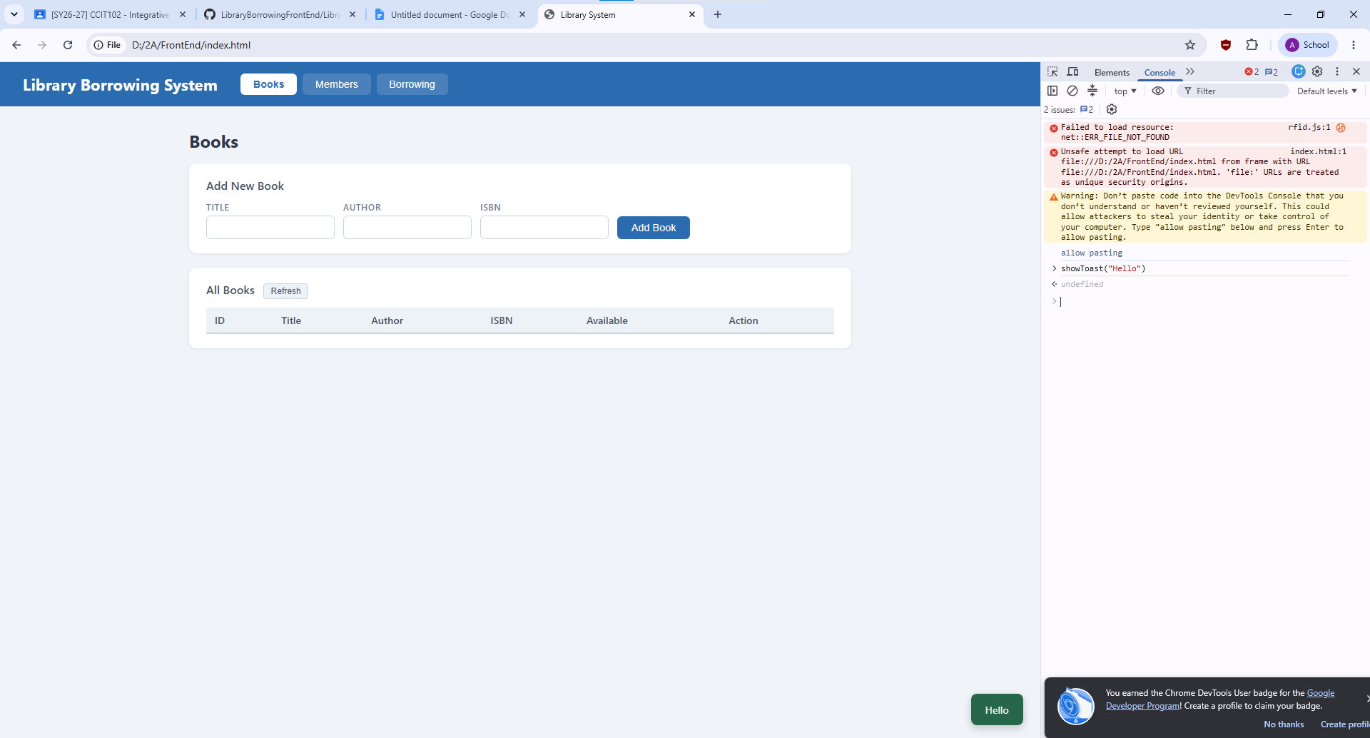
Code
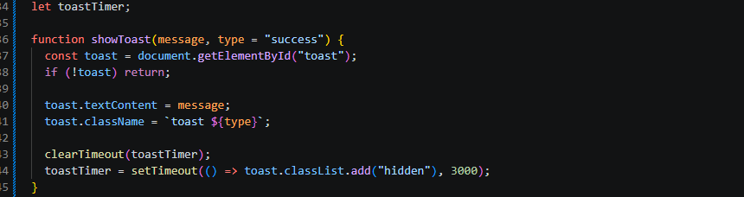

Part-03-caches SCREENSHOT 3
Function
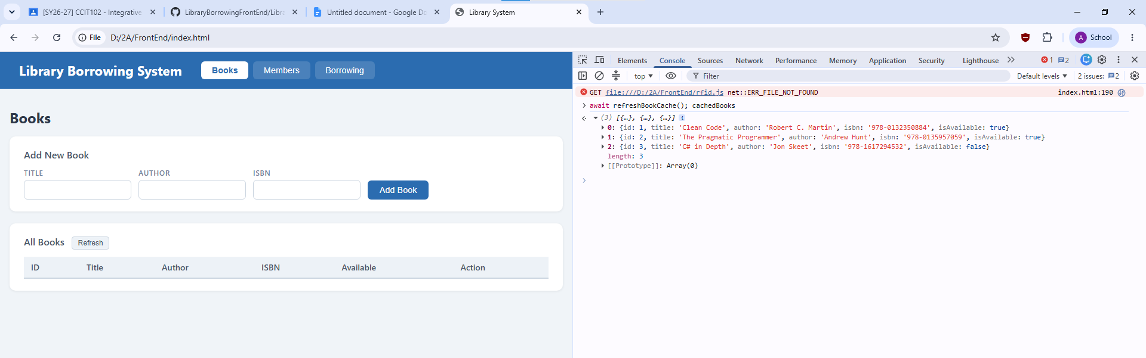
Code
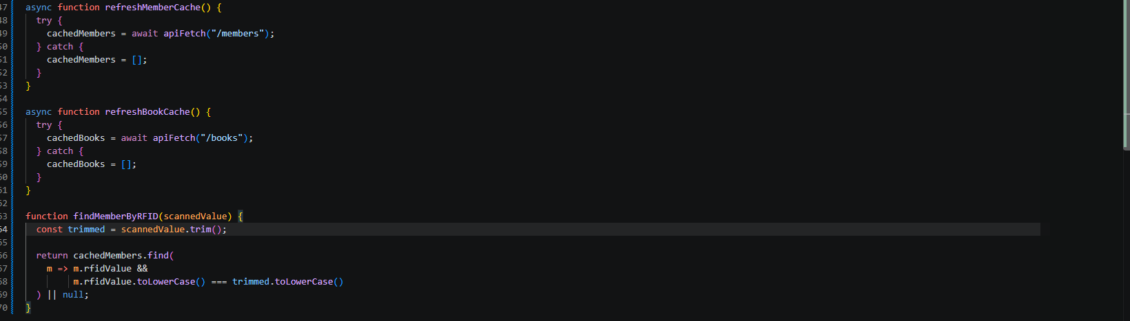

Part-04-tabs-refresh SCREENSHOT 4
Code
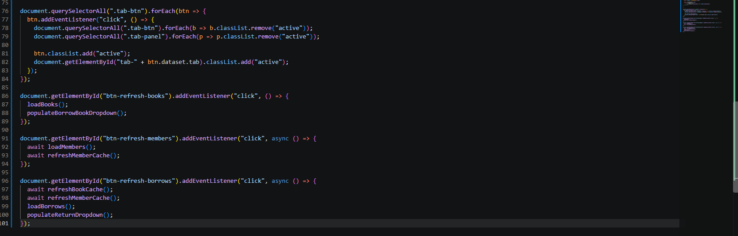
Function
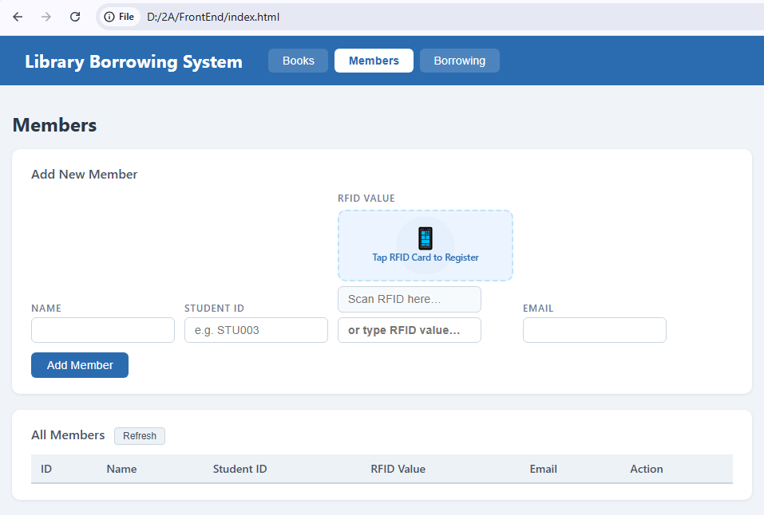

Part-05-loadbooks SCREENSHOT 5
Code
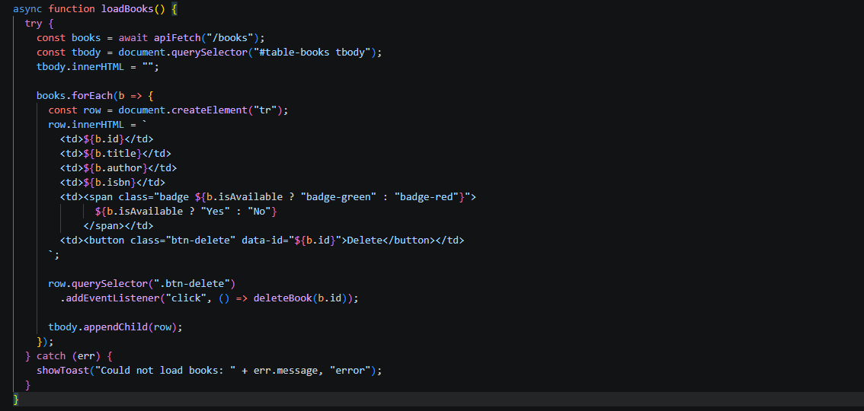

Part-06-deletebook SCREENSHOT 6
Code
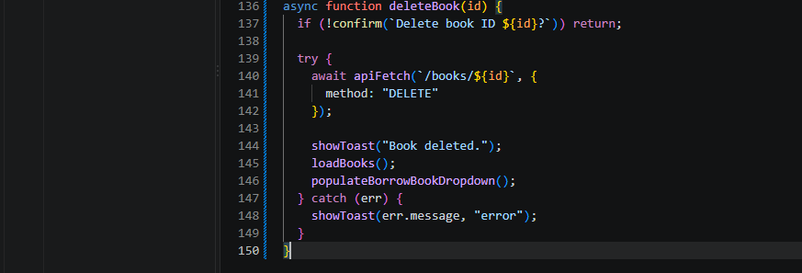

Part-07-addbook SCREENSHOT 7
Code
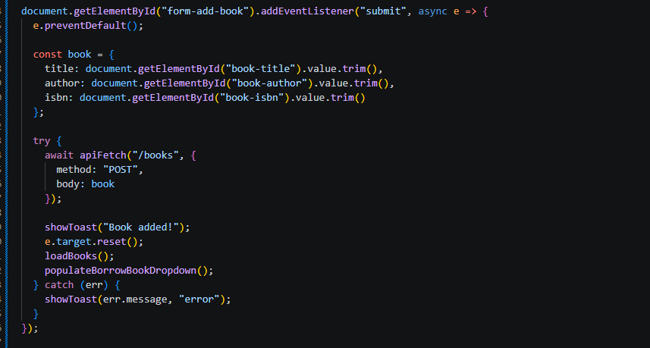

Part-08-loadmembers SCREENSHOT 8
Code
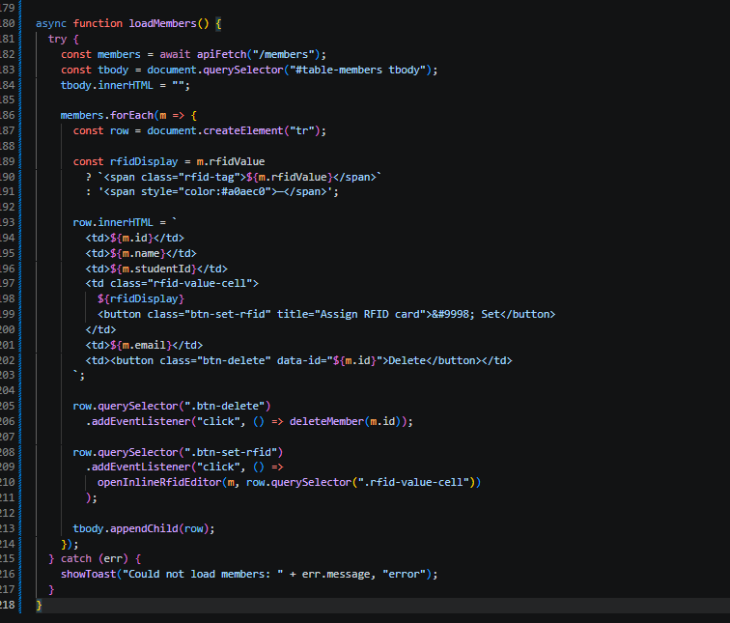

Part-09-deletemember SCREENSHOT 9
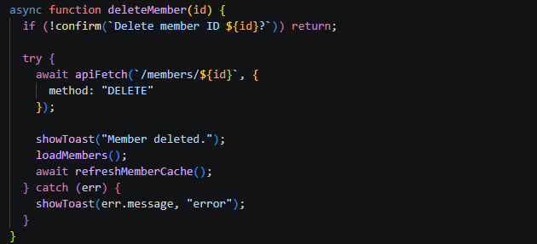

Part-10-addmember SCREENSHOT 10
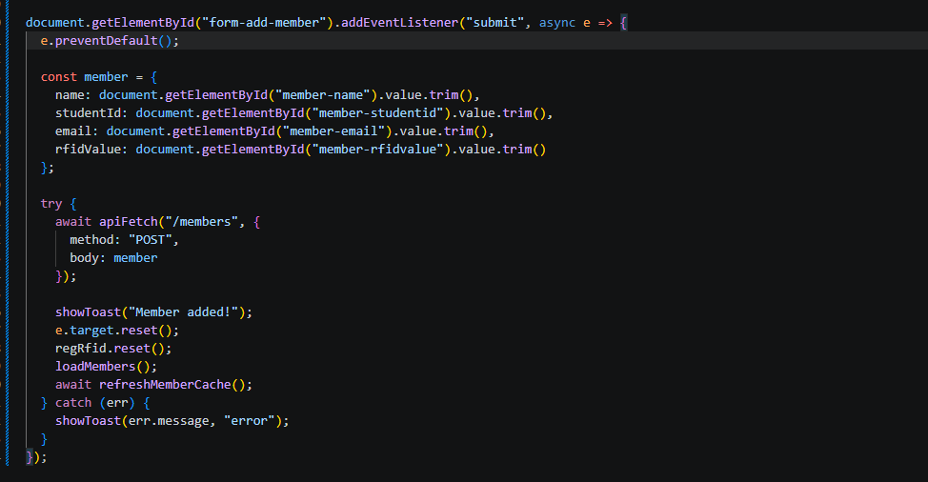

Part-11-inline-rfid-editor SCREENSHOT 11
Code
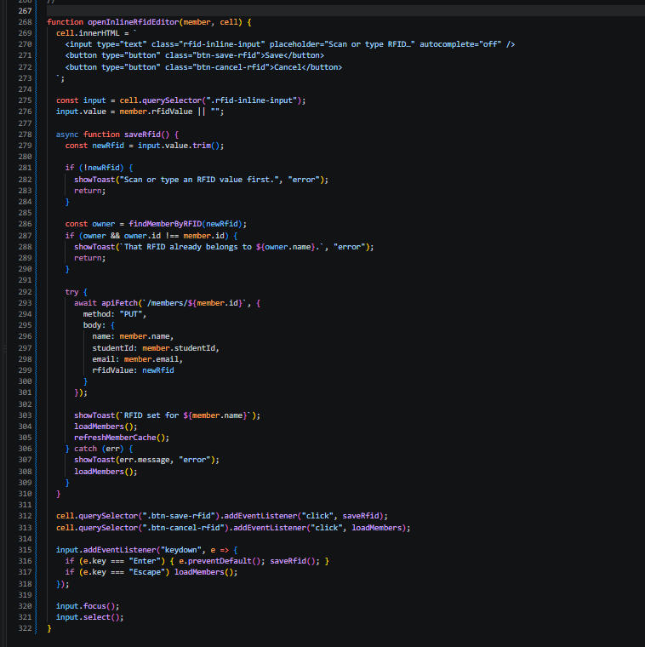

Part-12a-rfid-widget-builder SCREENSHOT 12
Code: createRfidWidget()
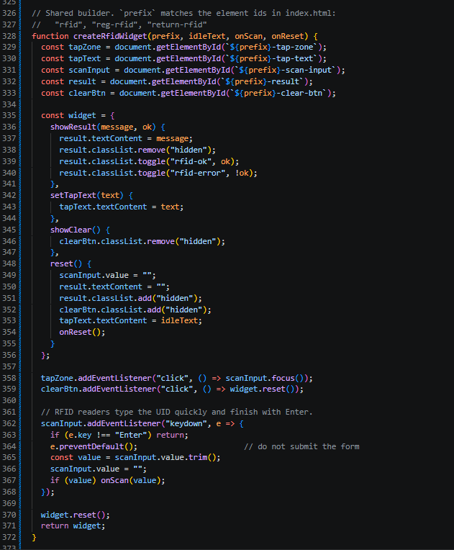

Code: initRFID()
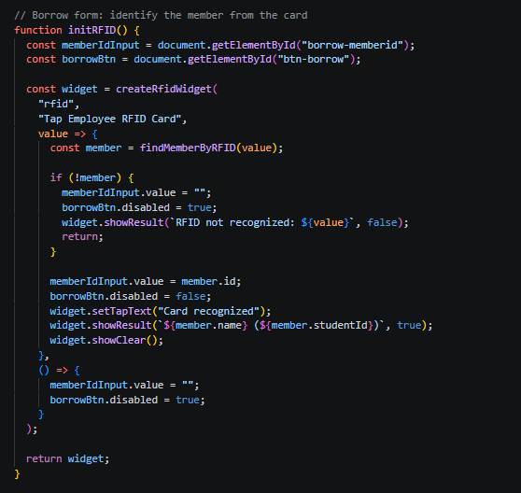

initRegRFID()
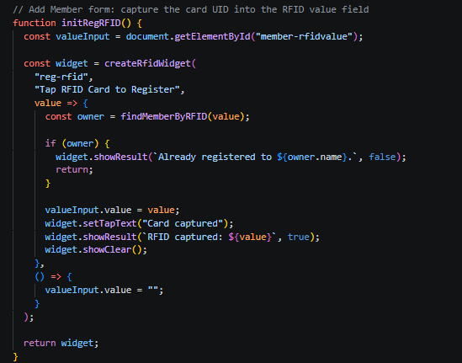

initReturnRFID()
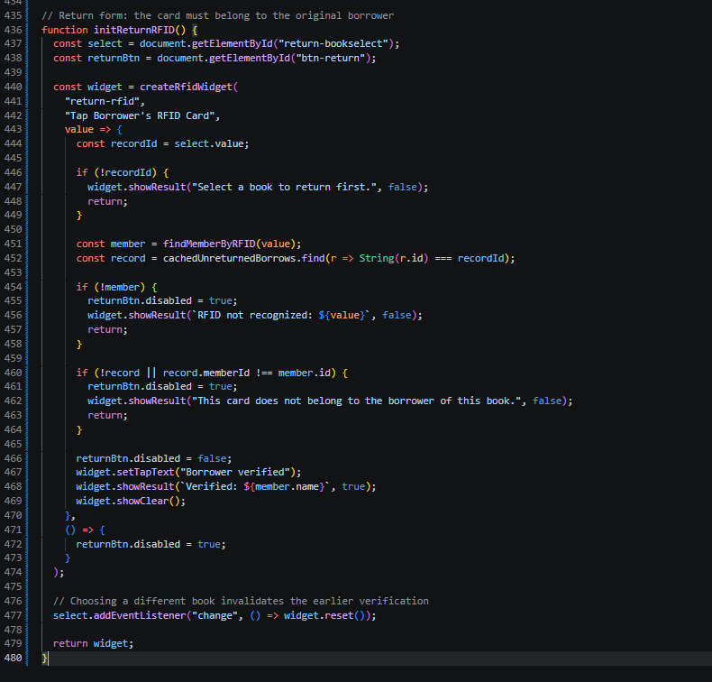

Part-13-borrow-dropdown SCREENSHOT 13
Code
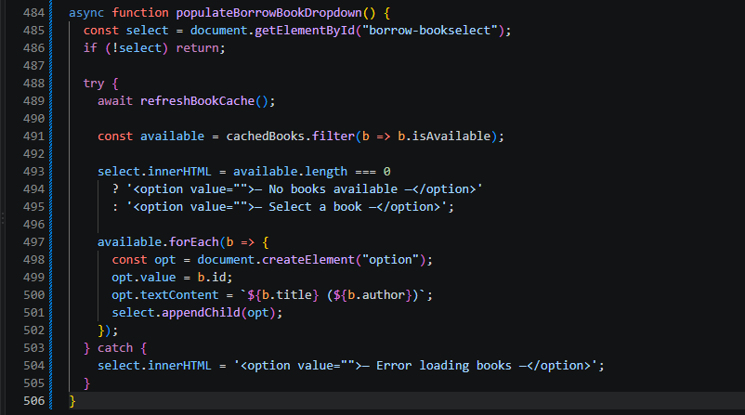

Part-14-return-dropdown SCREENSHOT 14
code
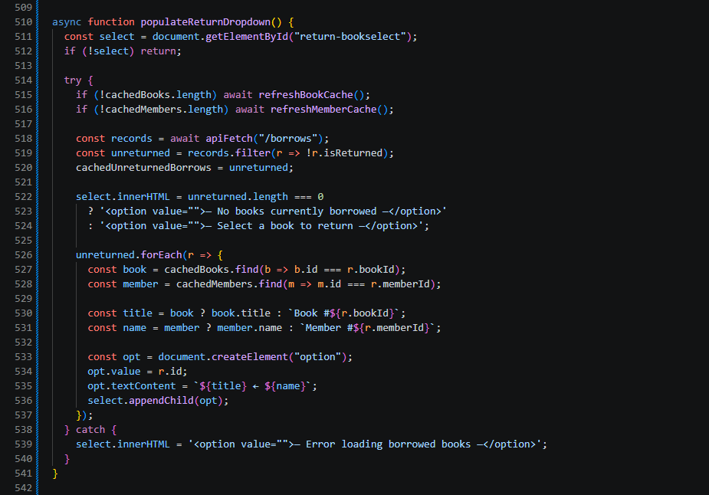

Part-15-borrow SCREENSHOT 15
code
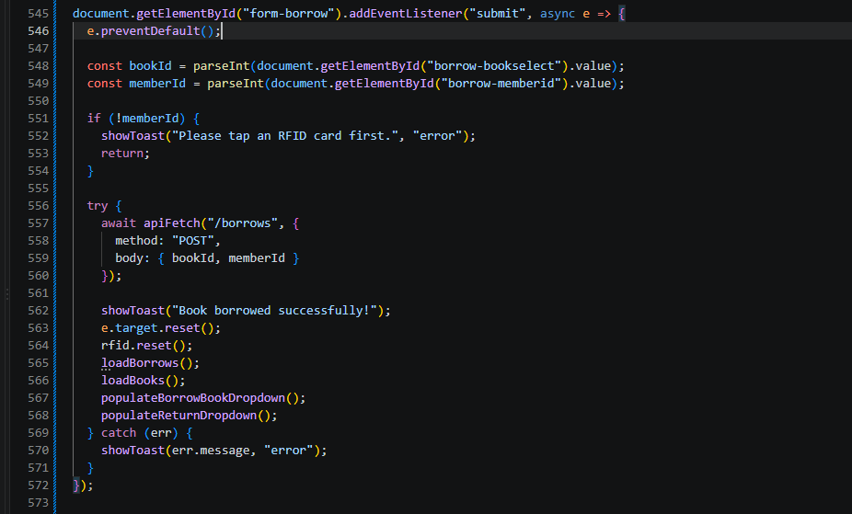

Part-16-return SCREENSHOT 16
code
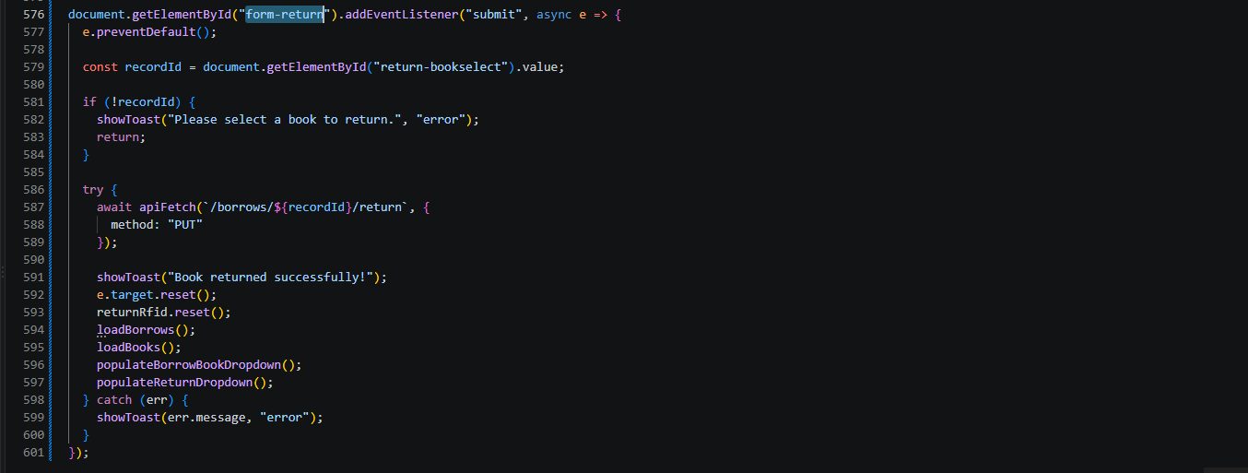

Part-17-loadborrows SCREENSHOT 17
Code
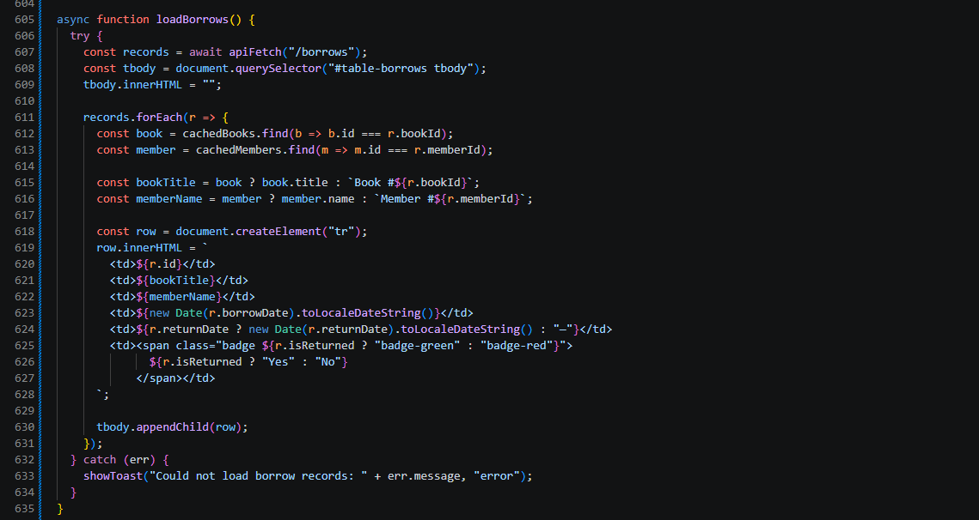

Part-18-page-load SCREENSHOT 18
Code:
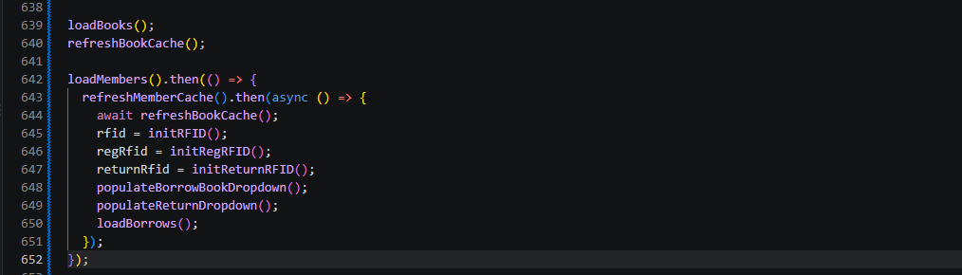

Test-01-page-loaded TESTING 1
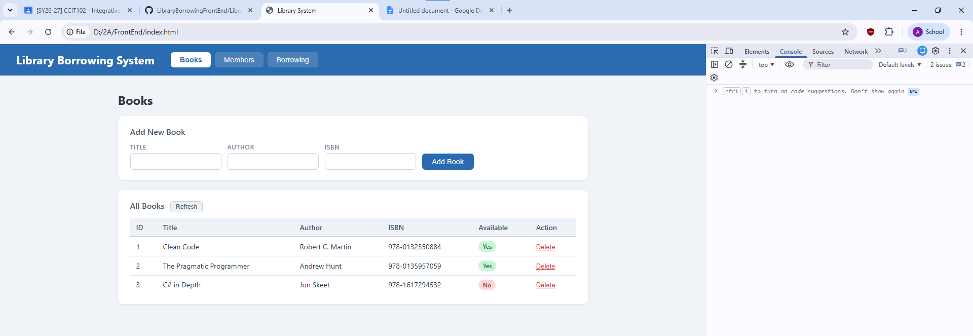

Test-02-add-book TESTING 2
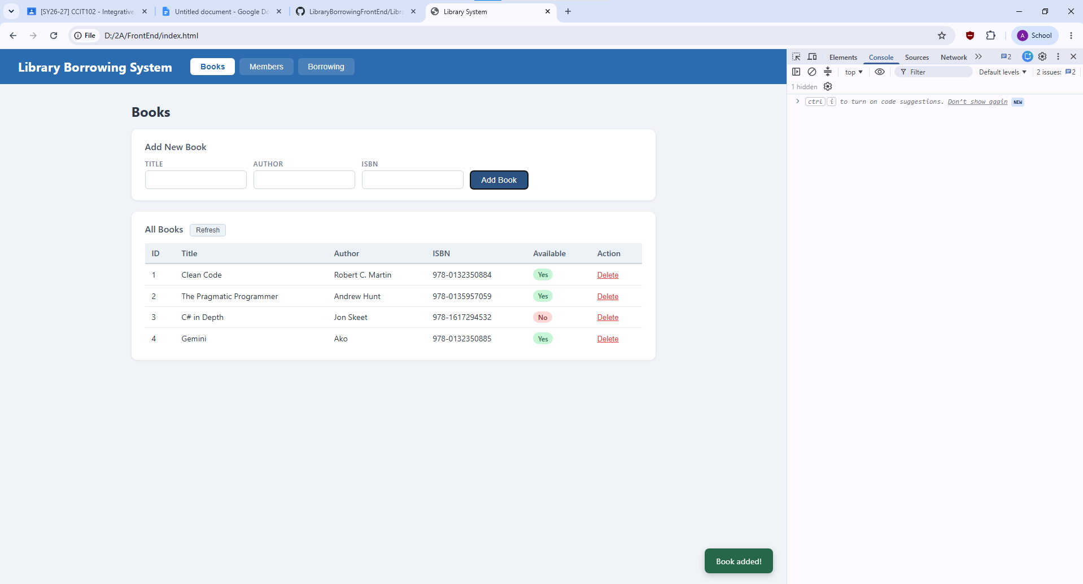

Test-03-delete-book TESTING 3
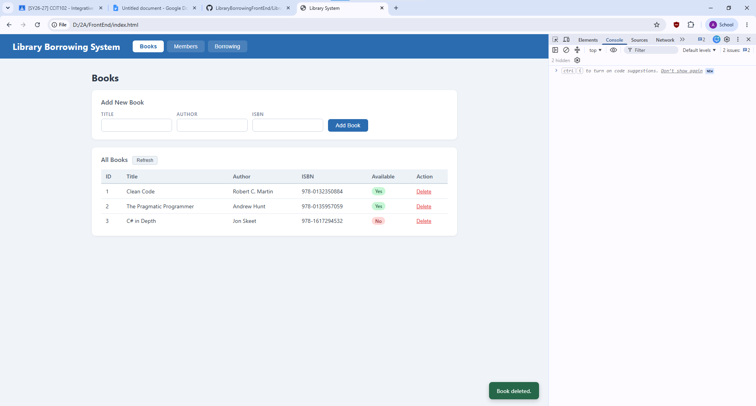

Test-04-members-loaded TESTING 4
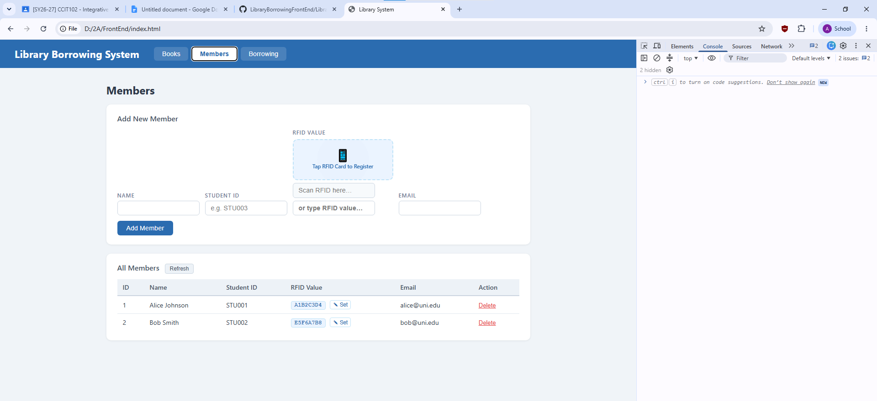

Test-05-register-rfid TESTING 5
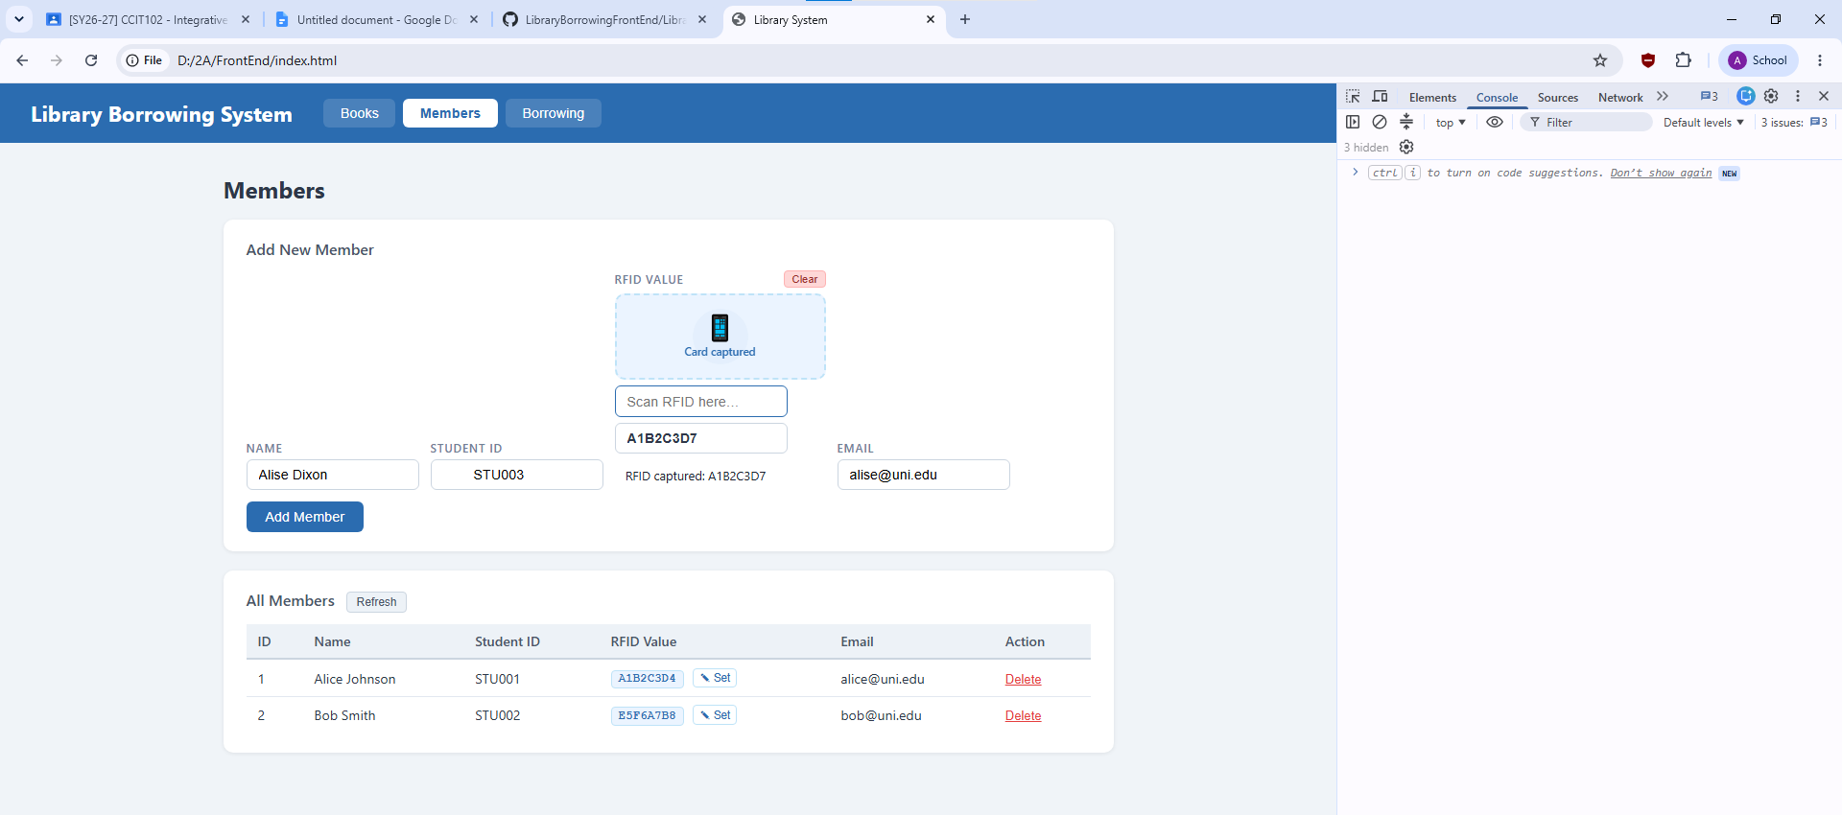

Test-06-add-member TESTING 6
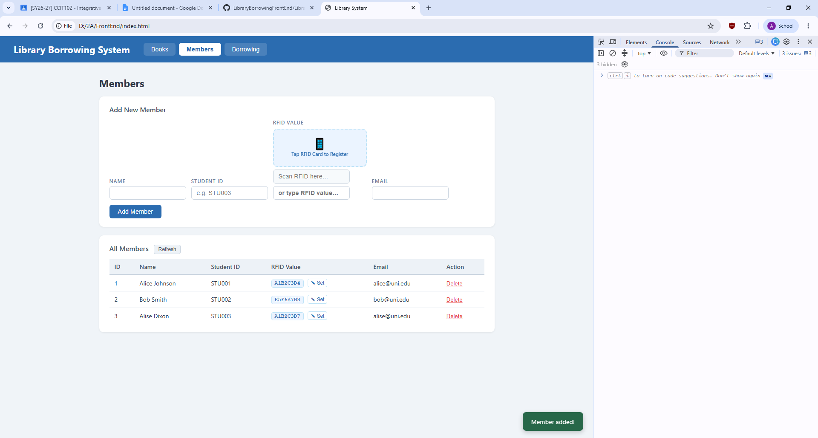

Test-07-set-rfid-saved TESTING 7
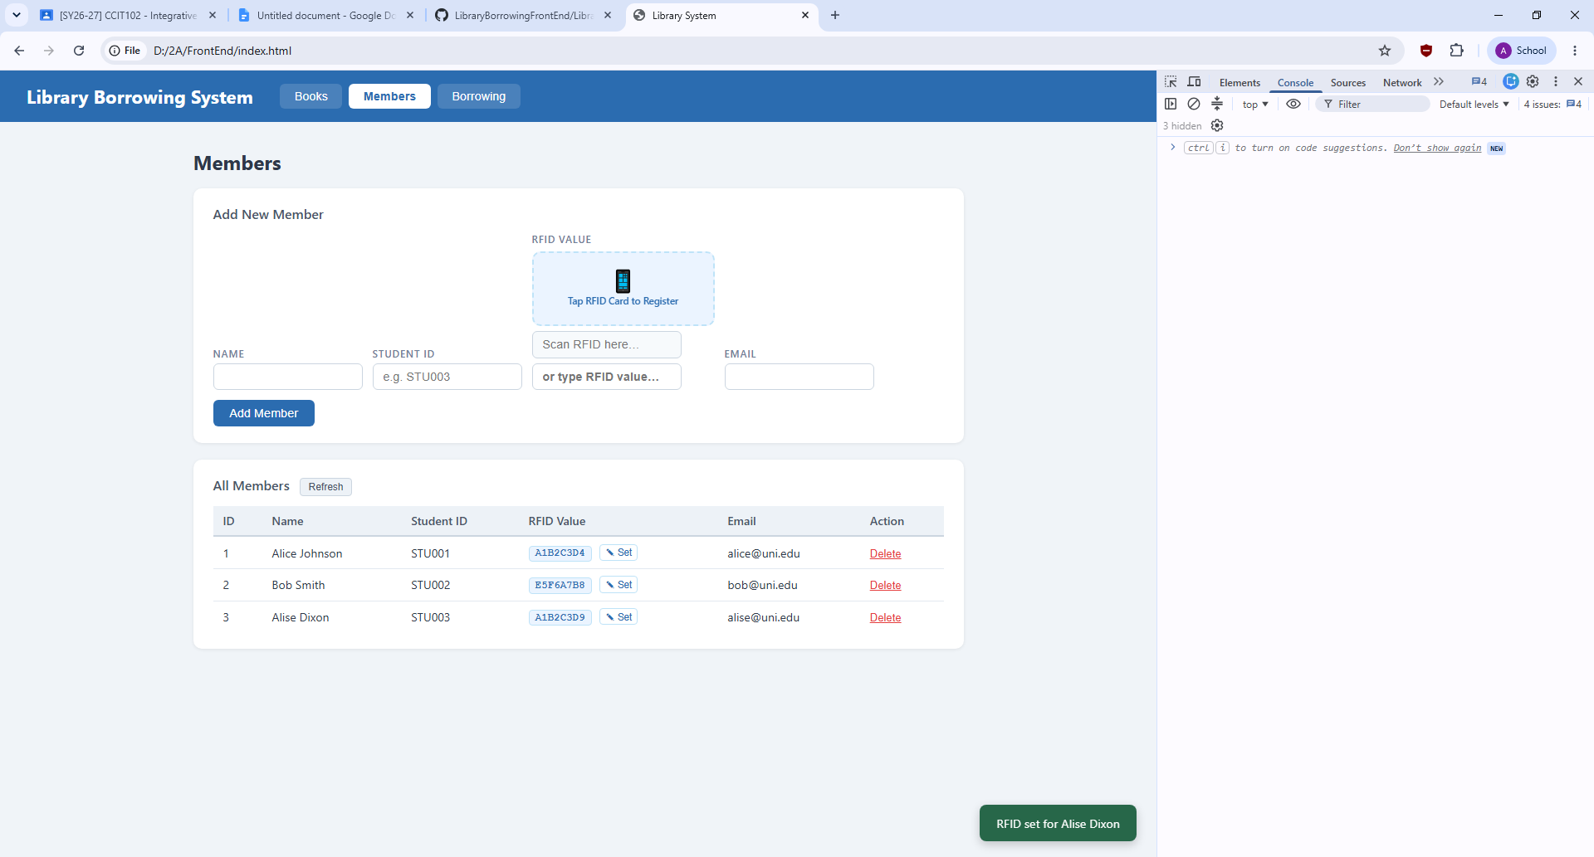

Test-08-delete-member TESTING 8
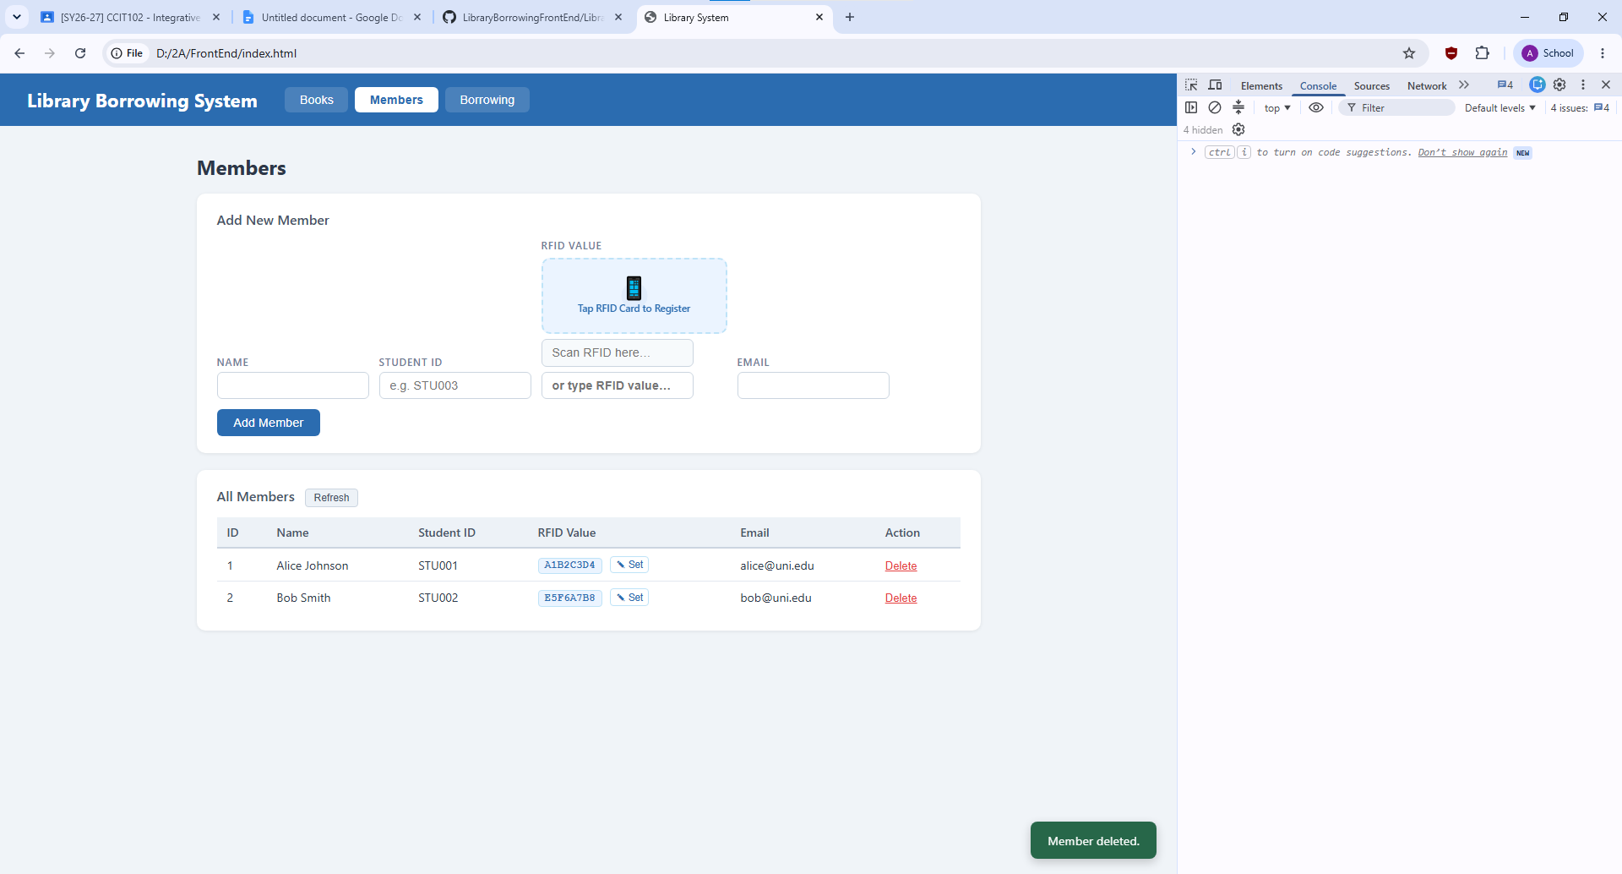

Test-09-borrow-rfid-recognized TESTING 9
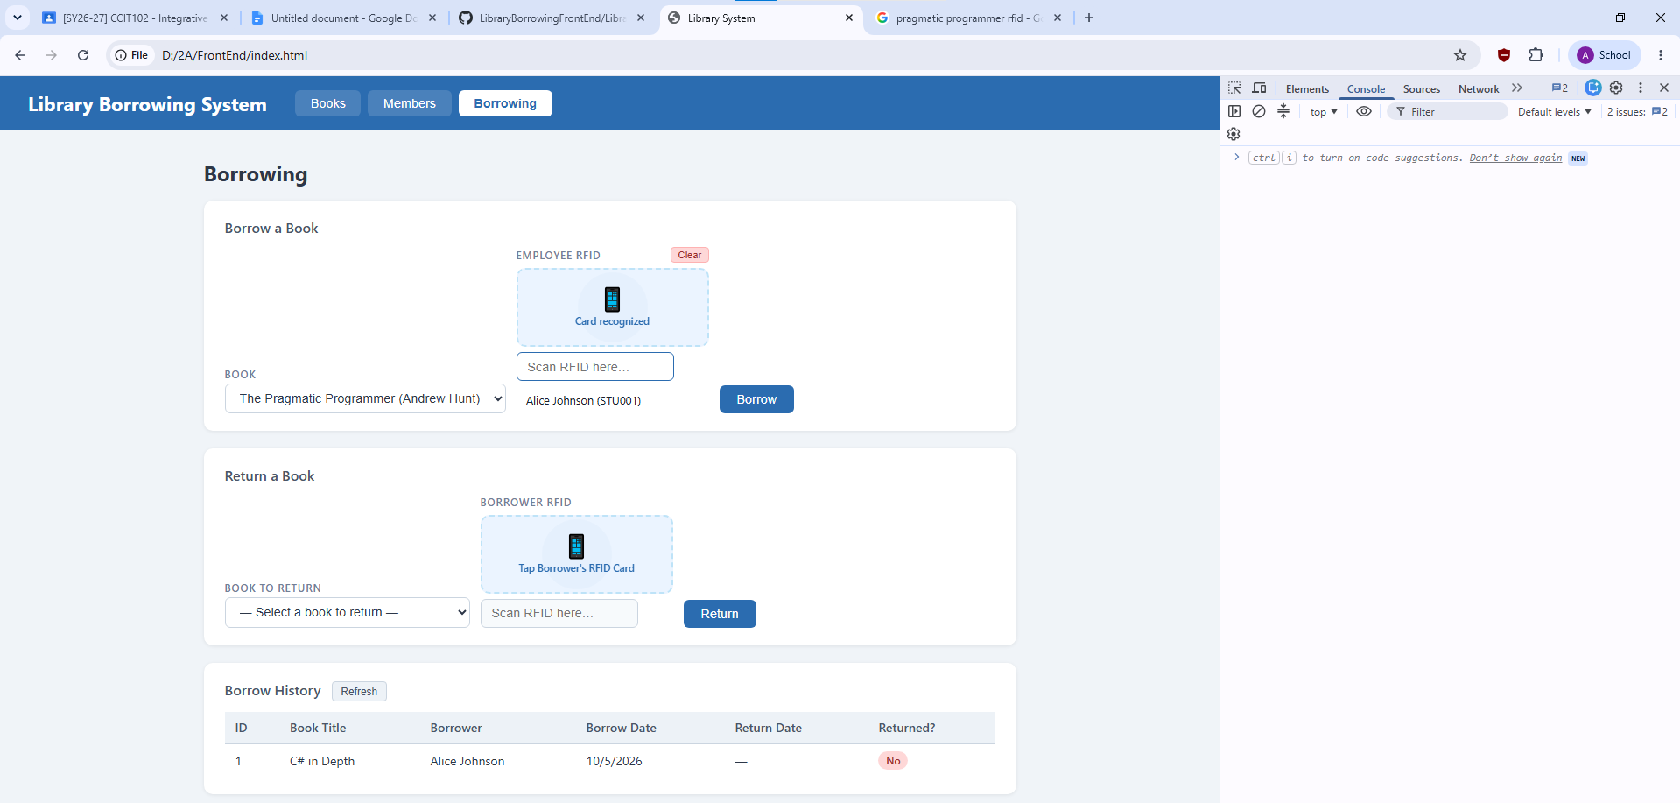

Test-10-borrow-success TESTING 10
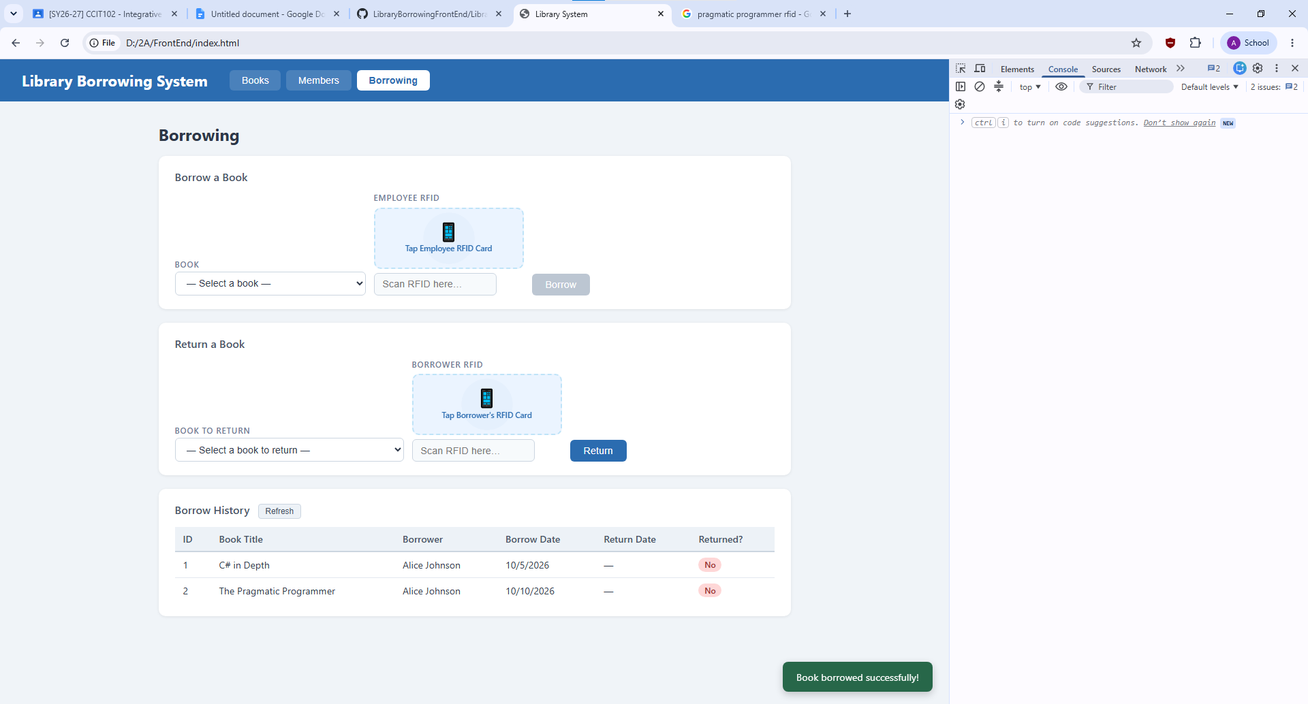

Test-11-return-wrong-card TESTING 11
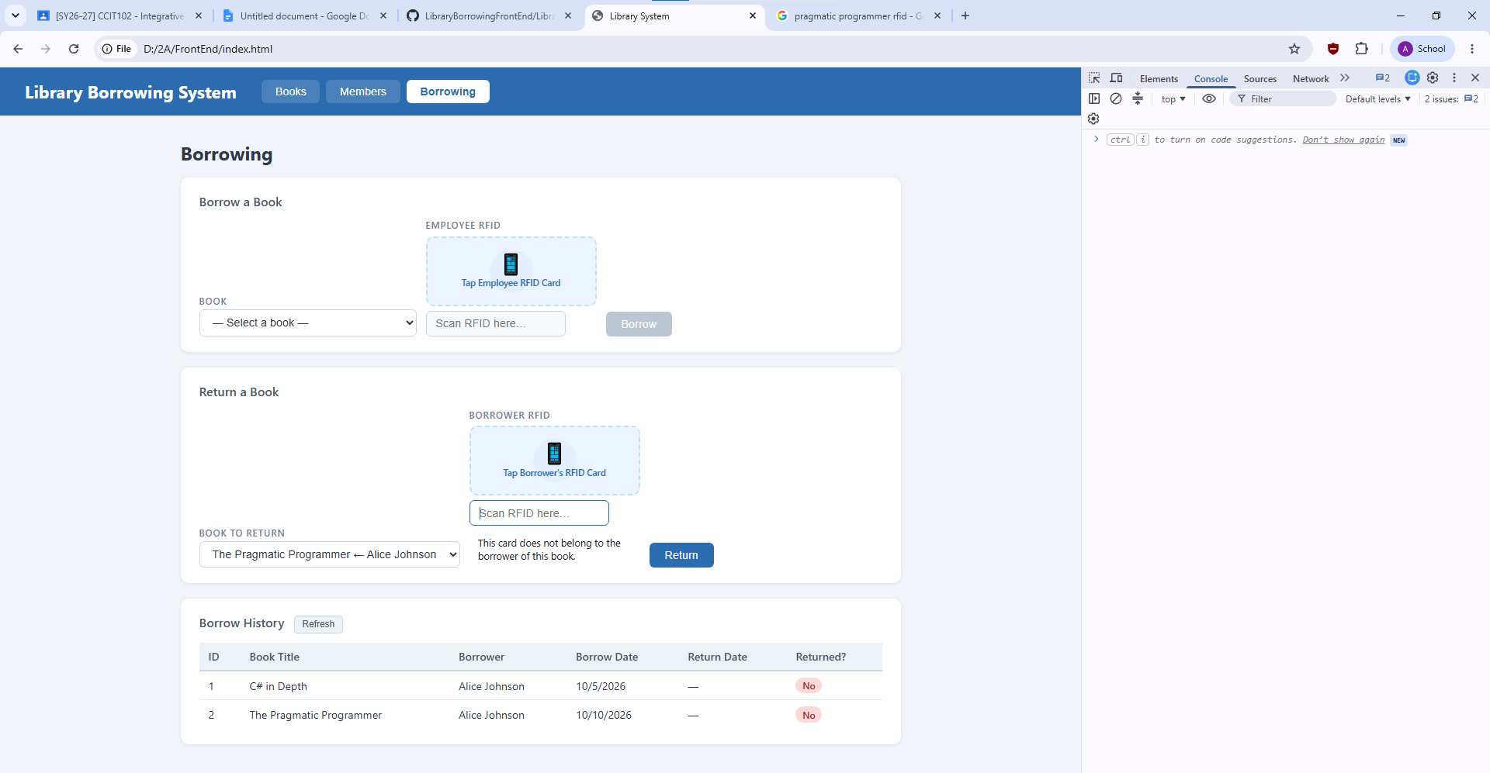

Test-12-return-verified TESTING 12
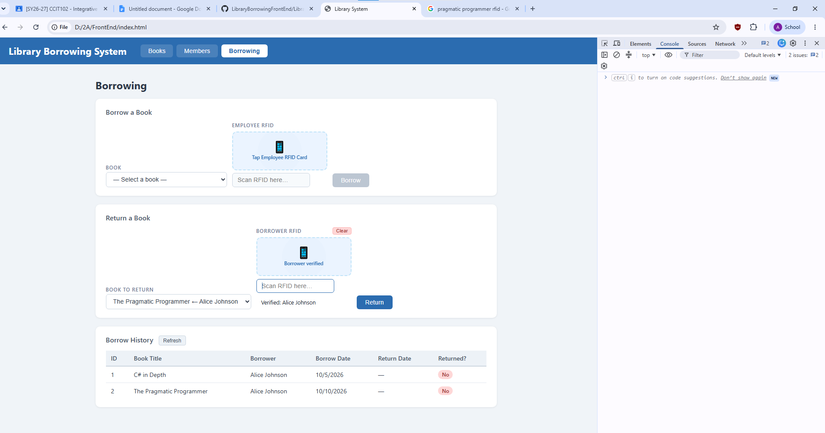

Test-13-return-success TESTING 13
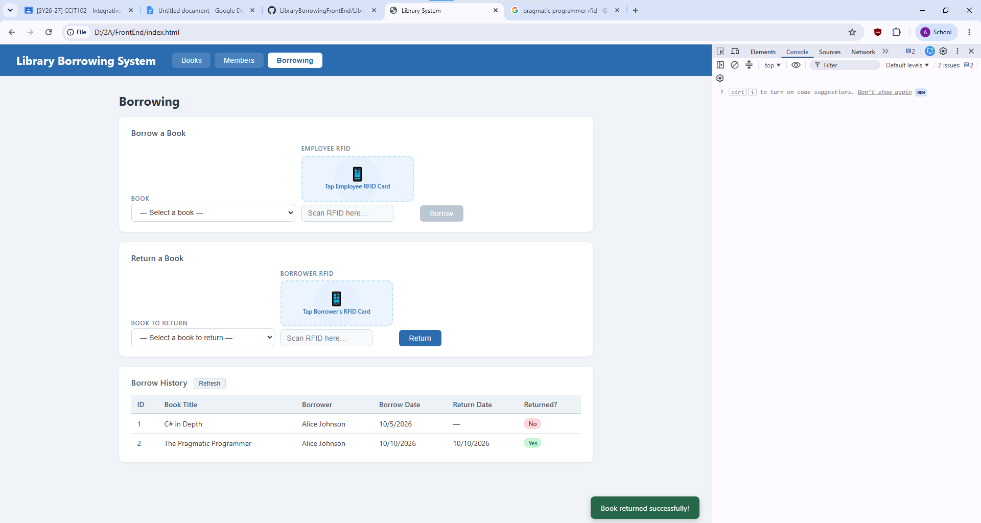

Test-14-final-console TESTING 14
